Feature Iteration Log 1

- Reseearch and Practice
Firstly small free courses were taking on the new technologies that were going to be implemented . This included understanding modularity structure in a Windows UI project, file flow and languages for frontend structure.
Practice was creating a simple app that displays simple stuff.
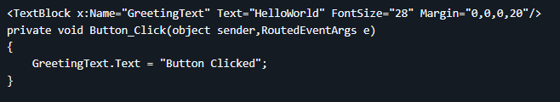
- Repository & Project creation :
WindowsUI C# project created. Research was done on the framework that would help with usability and clean flow of app compatible with the latest Windows version. WinUI project dependencies ensured.
- Separate Feature Windows Created
Home, Account and About pages created for the app . Structured with separate XAML and XAML.CS files where layout coded in XAML and logic coded in XAML.Cs which is C#.
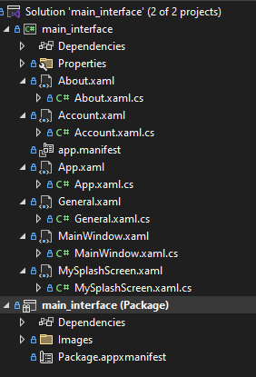
- Navigation Menu Created
XAML.CS Navigation Menu Created using Use Case statement to Nagivated to a certain page. The structure of the navigation menu had to be inherited onto all pages and each page had to display what page was active. This was done by the subclass ContentFrame.Navigate where <ContentFrame> is a UI property.
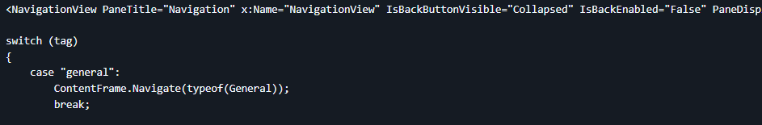
- Splash Screen Creation :
Application onLaunch function default rewritten to Launch separate XAML.CS window . The function had a sleep timer to ensure plash screen doesn’t cut out . Simple Graphic coded for visual effect. Upon Launch instance the splash screen will show instead of default main Home Page .
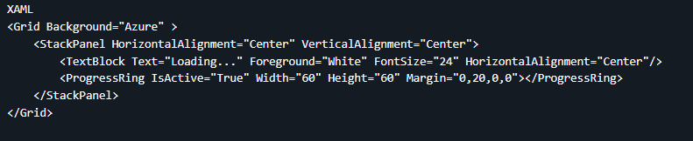

- Branching
Continuous Integration with a developmental branch was integrated so successive iterations could be implemented. This keeps the main branch stable and new features to be added isolated until can correctly fit into the project.
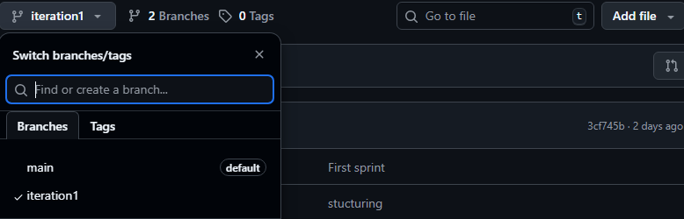

This concludes the first iteration , where the base app was created and the technologies to be implemented understood

REFERENCES
https://learn.microsoft.com/en-us/windows/apps/winui/winui3/create-your-first-winui3-app https://learn.microsoft.com/en-us/windows/apps/winui/ https://stackoverflow.com/questions/6925584/the-name-initializecomponent-does-not-exist-in-the-current-context https://learn.microsoft.com/en-us/dotnet/desktop/wpf/app-development/how-to-add-a-splash-screen-to-a-wpf-application https://www.youtube.com/watch?v=XM_I1y1mh7k

